TASK 3 REPORT
Task 3: Data Visualization
Objective:
To visualize the dataset using graphs for better understanding of patterns.
Code:
# ==============================
# STEP 1: IMPORT LIBRARIES
# ==============================

import pandas as pd
import matplotlib.pyplot as plt
import seaborn as sns

# ==============================
# STEP 2: LOAD DATA
# ==============================

df = pd.read_csv("traffic.csv", encoding='latin1')

print("First 5 rows:")
display(df.head())

# ==============================
# STEP 3: DATA CLEANING
# ==============================

df = df.dropna()
df = df.drop_duplicates()

# Convert date
df["date"] = pd.to_datetime(df["date"], errors='coerce')

# ==============================
# STEP 4: BASIC METRICS
# ==============================

# Total events (sessions approx)
total_sessions = len(df)

# Unique users (approx using country + city)
unique_users = df[["country", "city"]].drop_duplicates().shape[0]

print("Total Sessions:", total_sessions)
print("Unique Users:", unique_users)

# ==============================
# STEP 5: BOUNCE RATE (APPROX)
# ==============================

# If event type available (like click/view)
bounce_events = df[df["event"] == "view"].shape[0]

bounce_rate = (bounce_events / total_sessions) * 100

print("Bounce Rate (%):", bounce_rate)

# ==============================
# STEP 6: TOP LANDING PAGES
# ==============================

top_pages = df["linkid"].value_counts().head(10)

plt.figure()
top_pages.plot(kind="bar")
plt.title("Top Landing Pages")
plt.show()

# ==============================
# STEP 7: TOP COUNTRIES
# ==============================

top_countries = df["country"].value_counts().head(10)

plt.figure()
top_countries.plot(kind="bar")
plt.title("Top Countries")
plt.show()

# ==============================
# STEP 8: EVENT TYPE ANALYSIS
# ==============================

plt.figure()
sns.countplot(x="event", data=df)
plt.title("Event Type Distribution")
plt.show()

# ==============================
# STEP 9: TIME ANALYSIS
# ==============================

df["day"] = df["date"].dt.day

daily_traffic = df.groupby("day").size()

plt.figure()
daily_traffic.plot()
plt.title("Daily Traffic Trend")
plt.show()

# ==============================
# STEP 10: TOP TRACKS (CONTENT)
# ==============================

top_tracks = df["track"].value_counts().head(10)

plt.figure()
top_tracks.plot(kind="bar")
plt.title("Top Tracks (Content)")
plt.xticks(rotation=45)
plt.show()

# ==============================
# STEP 11: FINAL OUTPUT
# ==============================

print("\nFinal Data:")
display(df.head())

Output:
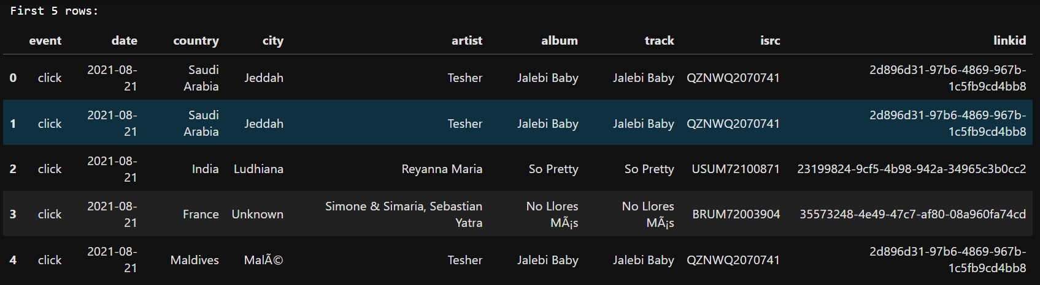
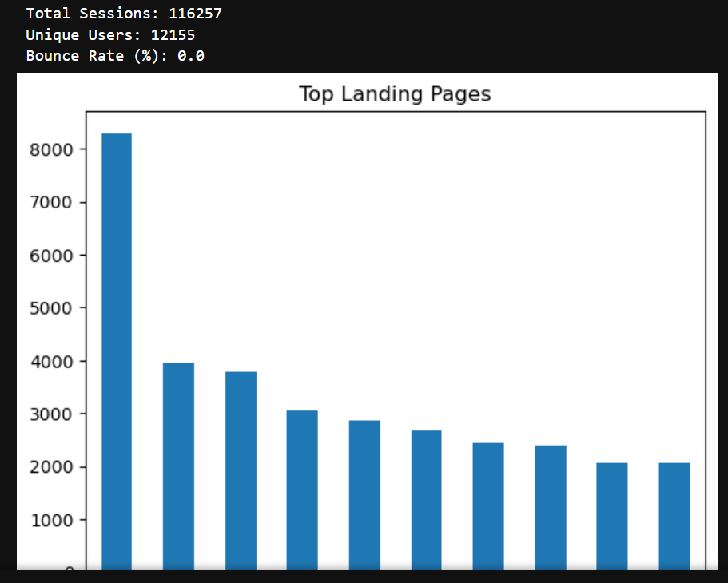
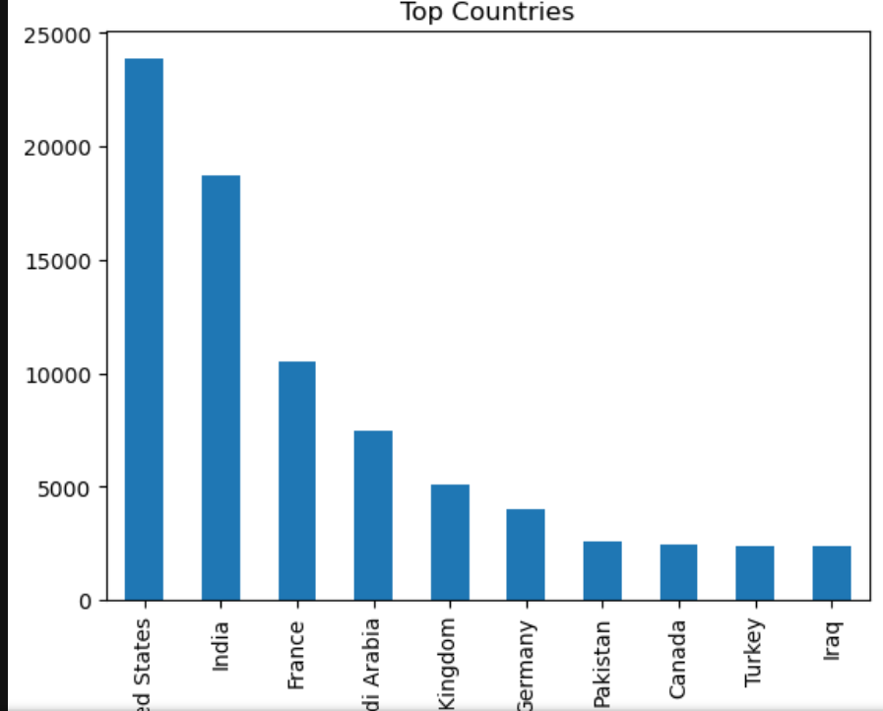
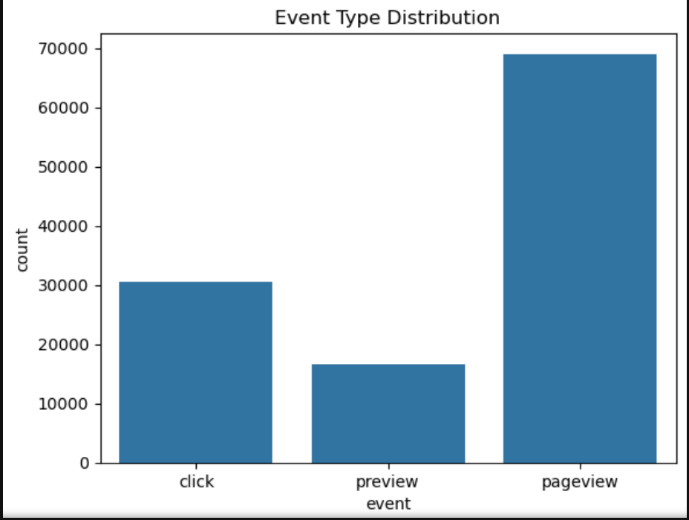
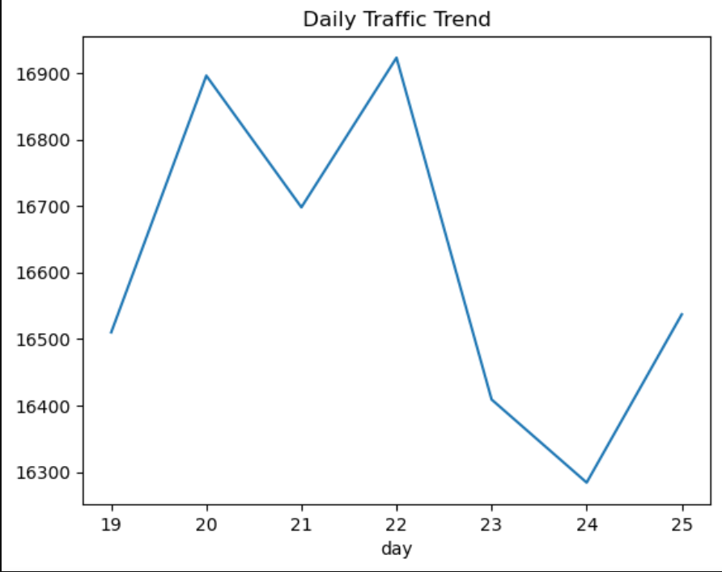
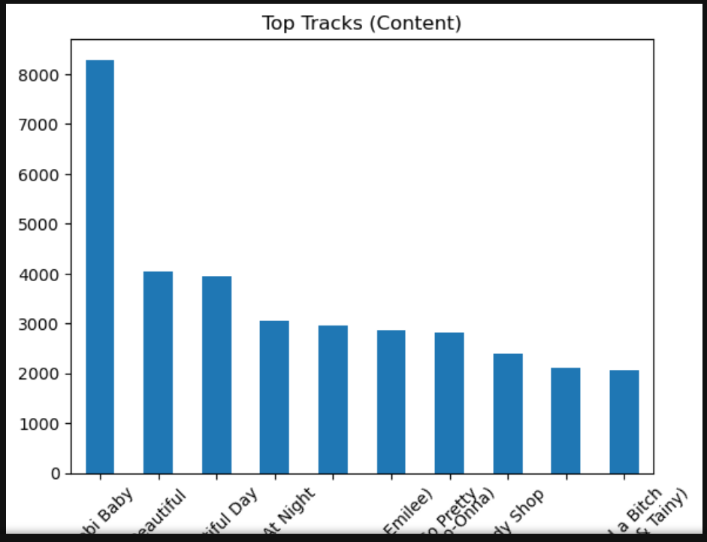
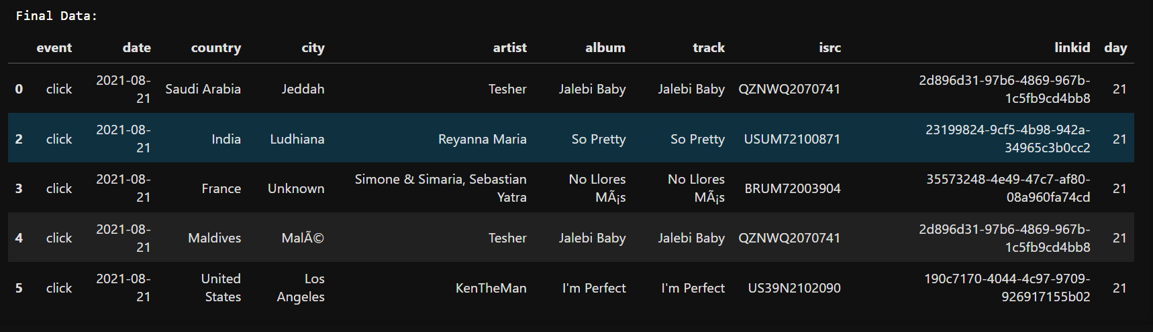

Summary:
In this task, various visualizations were created using Python libraries. Graphs helped in identifying patterns, trends, and relationships within the data. Visualization makes complex data easier to understand and supports better decision-making.

